NATIONAL GUIDELINES ON THE APPLICATION OF THE DNSH PRINCIPLE

Cover document to the DNSH guidelines

DELIVERABLE 5

WWW.TRINOMICS.EU

This project is carried out with funding by the European Union via the Technical Support Instrument and in cooperation with the Directorate General for Structural Reform Support of the European Commission

Contract details

REFORM/SC2022/112 - Methodology for the application of the DNSH principle at the national level in Czechia

Presented by

Trinomics B.V.

Mauritsweg 44

3012 JV Rotterdam

The Netherlands

Contact person

Mr. Peter Janoska (Project Manager)

E: [peter.janoska@trinomics.eu](mailto:peter.janoska@trinomics.eu)

Date

Rotterdam, 03/07/2024

Rotterdam , 03/07/2024

[REFORM/SC2022/112]

[Title]

|  |  |  |  |  |
| --- | --- | --- | --- | --- |
| In association with: | | | | |
|  | |  |  |  |  | |
|  | |  |  |  |  | |
|  | |  |  |  |  | |
|  | |  |  |  |  | |

# Objectives

National guidelines on the application of the DNSH principle have been developed as a part of the TSI project “Methodology for the application of the DNSH principle at the national level in Czechia”.

Their aim is to produce overarching methodological guidelines building on existing Commission and national guidance for both 1) authorities managing the public investments and 2) project implementers/grant beneficiaries. The separate guidelines will aim to help all actors apply the DNSH principle, and to assess infrastructure against the climate proofing methodology, when required, in a fit-for-purpose way. In addition, the following objectives reflect the needs of the Czech authorities:

1. Where possible, **building on and/or refer to existing guidelines** at the Czech level (e.g., guidelines developed by the Ministry of Environment).
2. **Reducing the administrative burden for project proponents**, in particular SMEs (e.g., where possible, moving responsibilities from the proponents to the Czech authorities).
3. **Providing non-binding suggestions[1] in a different format** (italics) than instructions deriving from the Commission official guidance. Non-binding suggestions should support Czech authorities where the official guidance does not offer specific advice (e.g., on monitoring).

# Process

The development of guidelines was conducted between May 2023 and March 2024. It thus reflects the evolutions of the regulatory context at the European level (e.g., publication of an updated Commission Notice for applying the DNSH principle to the Recovery and Resilience Facility[2]) and of the operational context in Czechia (e.g., advancement of ongoing investments and pressing need for monitoring their implementation). The development of the guidelines has thus been a highly iterative process, which led to the following scope:

* The guidelines **focus on the Recovery and Resilience Facility (RRF) and the Cohesion Policy Funds (CPFs)**. Their respective methodologies are presented separately.
* The guidelines mirror the official guidance provided by the EC and focus on the processes needed to implement the guidance’s instructions. **Interpretations of the guidance are avoided**. The operational advice represents transposition of the official guidance to practical steps.
* The deliverable includes **templates, which will be tested under deliverable 7** (“Pilot implementation of the national DNSH guidelines”).
* Methodologies of relevance to the DNSH principle (strategic environmental assessments (SEA), environmental impact assessments (EIA), sustainability proofing (SP), climate proofing (CP)) are **not explored in-depth but touched upon where they include elements relevant for the DNSH application**.

# Structure

Guidelines include the following 3 components:

1. **Methodological guidelines for managing authorities** of non-binding nature, building on existing Commission and national guidance.
2. **Methodological guidelines for project implementers/grant beneficiaries** of non-binding nature. These are used where managing authorities may not assess a project’s or operation’s alignment with the DNSH principle based on the call criteria. They provide guidance for the project proponents to assess their project or operation in more detail, beyond the call’s criteria.
3. Annexes providing **recommendations for roles and responsibilities** amongst involved parties to implement the overarching DNSH guidelines, to implement **monitoring and verification best practices**, and to collect and manage verifying **data**.

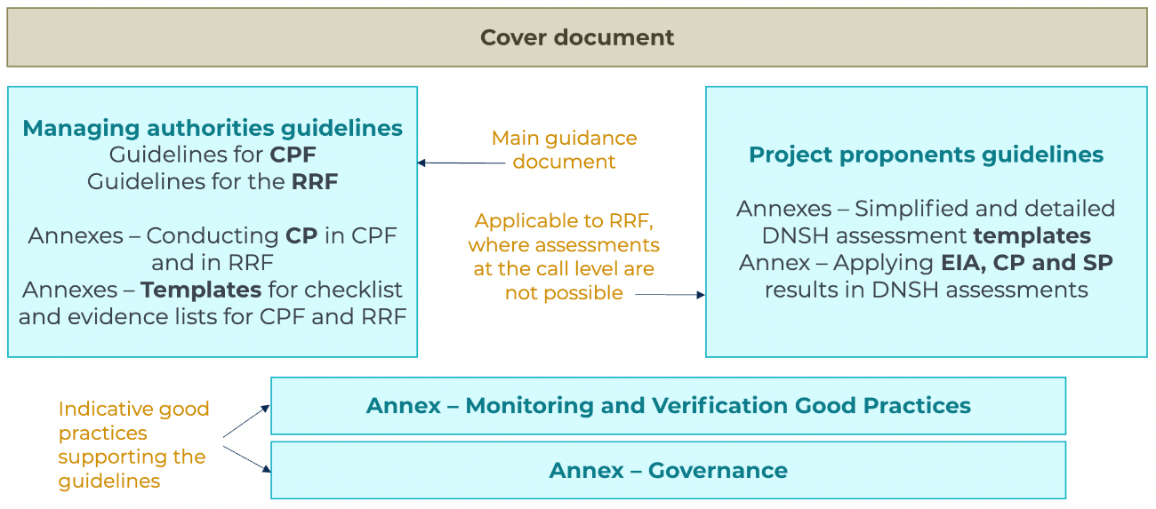

# Overview of the approach to DNSH

Based on the parallel requests to develop both separate and streamlined methodology for RRF and CPFs, the Managing Authorities Guidelines revolve around the same structure but different sub-steps and documents. An overview of this structure is provided below.

Overview of the structure for CPF

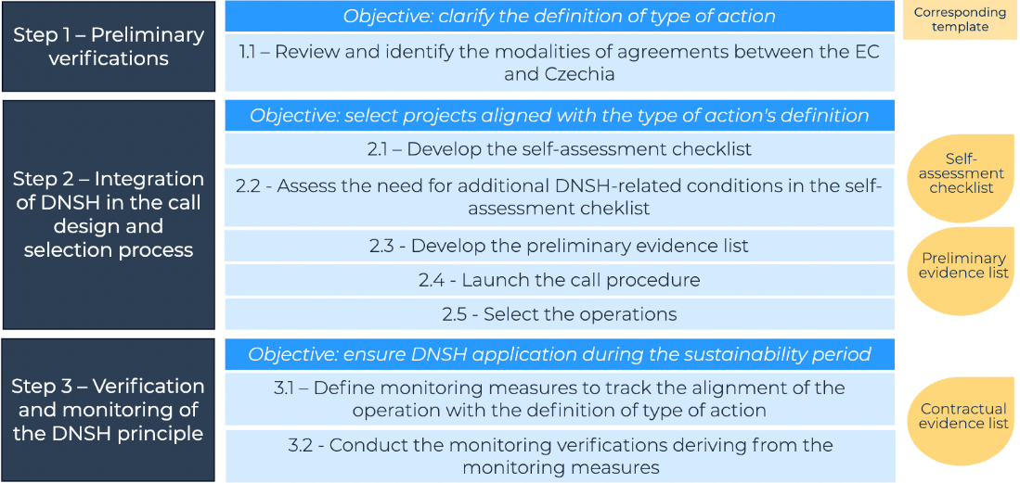

Overview of the structure for RRF

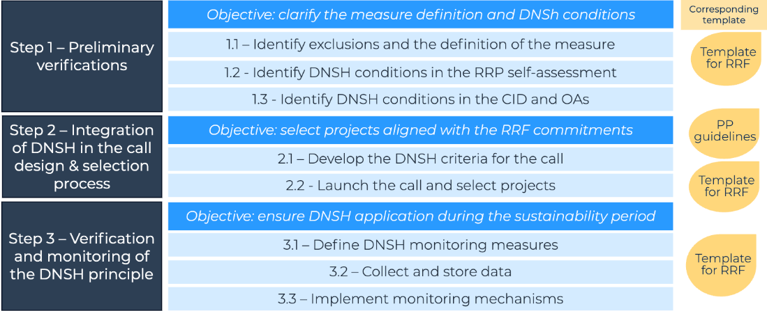

Trinomics B.V.  
Westersingel 34  
3014 GS Rotterdam  
The Netherlands

T +31 (0) 10 3414 592  
[www.trinomics.eu](http://www.trinomics.eu)

KvK n°: 56028016  
VAT n°: NL8519.48.662.B01

1. Binding guidelines include the Notice “Technical guidance on the application of “Do No Significant Harm” under the RRF (C/2023/111) and the Explanatory Note “Application of the “Do No Significant Harm” Principle under Cohesion Policy” (EGESIF_21-0025-00).
2. Technical guidance on the application of "Do No Significant Harm" under the Recovery and Resilience Facility Regulation (C/2023/111)